**Ideation phase**

**Brainstorm & Idea Prioritization**

|  |  |
| --- | --- |
| **Date** | 30 September 2022 |
| **Team Id** | PNT2022TMID46988 |
| **Project Name** | Project--5833-1658817449 |
| **Maximum Marks** | 4 Marks |

**Reference:** https://app.mural.co/t/santhanakumar5084/m/santhanakumar5084/1665897280730/1557e218e5082476597b74fbcb36c6cb47cc8f56?sender=u692b56718e70edb435c58035

**Step-1: Team Gathering, Collaboration and Select the Problem Statement**

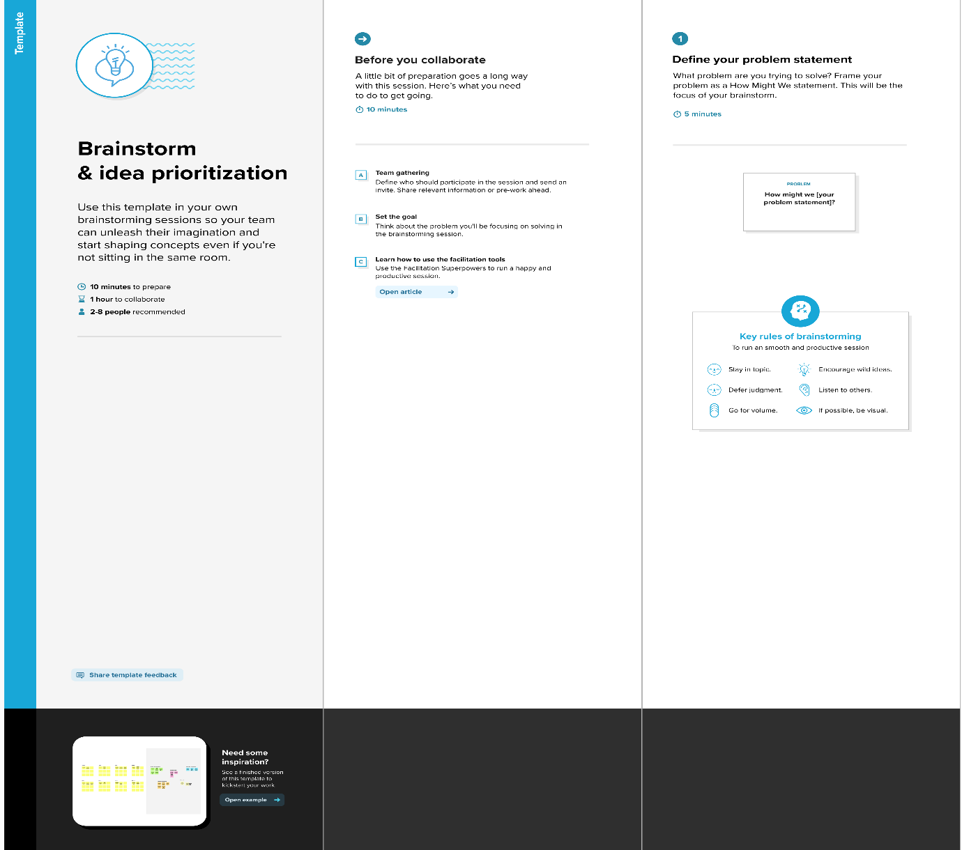

**Step-2: Brainstorm, Idea Listing and Grouping**

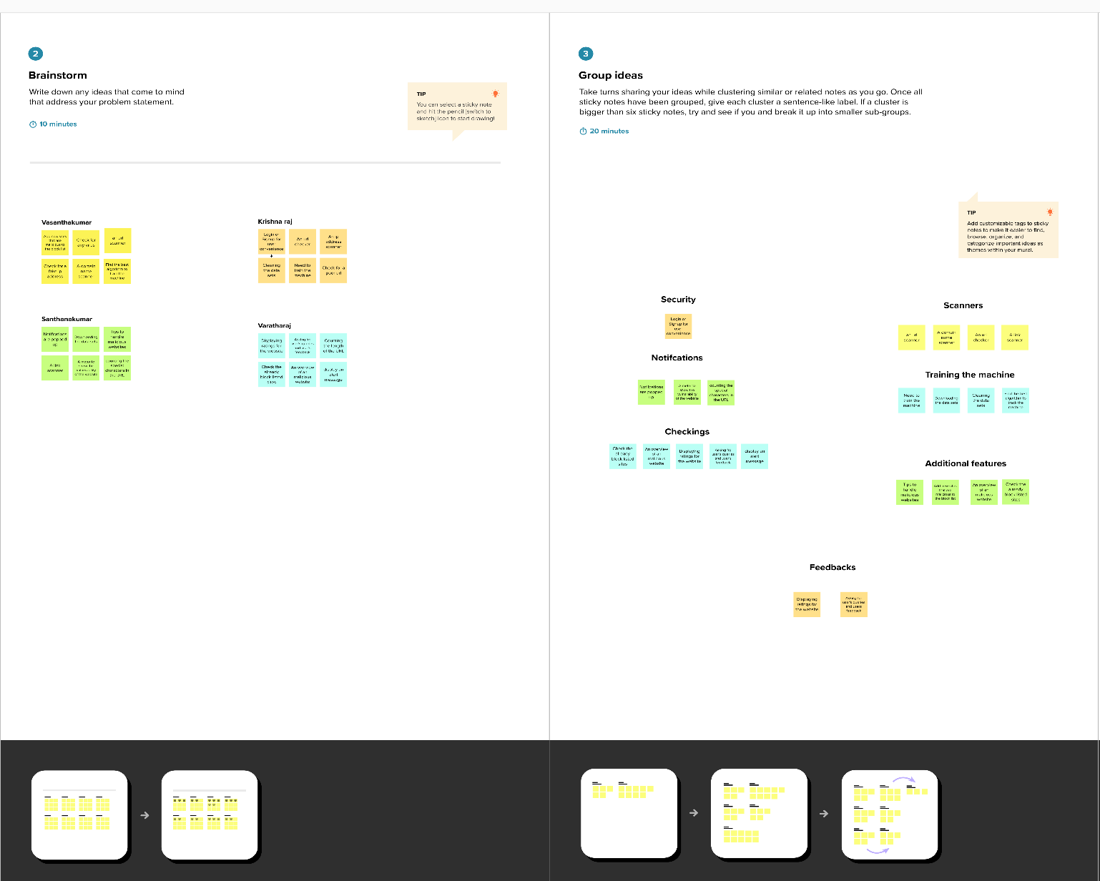

**Step-3: Idea Prioritization**

